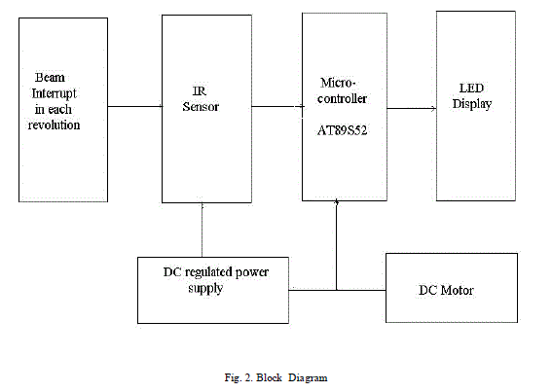

Micro-controller Atmega 32u4

Turnigy Motor

Regulated DC Power Supply

LED’s Display

EEPROM

Hall Effect Sensor